

**Domestic Abuse Accommodation Support Worker**

**Job Information Pack**

**November 2024**

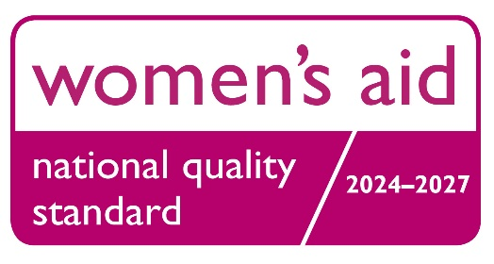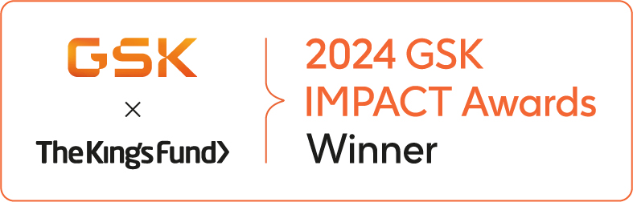

Rising Sun Domestic Violence and Abuse Service

Charity no. 289253

# Introduction to the Rising Sun Domestic Violence & Abuse Service

Rising Sun is a charity in Kent working to end domestic abuse and improve the lives of survivors and their children suffering from its effects. We have an ambitious vision for a world in which women and children live free from actual or threatened domestic abuse and all forms of violence.

Established in 1978, we represent, campaign for, and support the delivery of specialist domestic abuse and prevention of violence against women and girls services in Kent, as part of a UK network.

We have been at the forefront of shaping coordinated community responses and practice in Kent, by campaigning for change and providing advice, support and training to deliver programmes and services for survivors, families and communities.

As a part of the Women’s Aid national federation, we ground our work and campaigning, as well as our training and advocacy, in delivering our local specialist services. We found our success on making sure the experiences and needs of survivors are central to all we do.

Rising Sun provides an integrated and holistic service addressing the needs of survivors and their children from the point of crisis through recovery and onto independent lives. Our key underlying principle is to work holistically alongside survivors in their recovery from the trauma they have experienced; helping to build resources through a strengths-based approach so that survivors are able to build safe and independent futures.

# Vision and Mission

Our **vision** is a world in which women and children live free from actual or threatened domestic abuse and all forms of violence.

Our **mission** is to provide specialist support to women, children and anyone affected by domestic abuse across Kent. We aim to:

* Prevent domestic abuse.
* Provide specialist services for survivors of domestic abuse which are survivor centred, trauma informed and gender responsive.
* Work in partnership with survivors and other services to provide a holistic and meaningful response to bring about lasting change.
* Advocate for survivors and provide a platform for their voice to be heard.

# Our Framework

The Rising Sun Framework is threaded through every aspect of the organisation, it combines our values and approach, with our vision firmly at the centre. Our Framework enables us to fulfil our mission alongside increasing job satisfaction and wellbeing for team members and improving organisational health and processes.

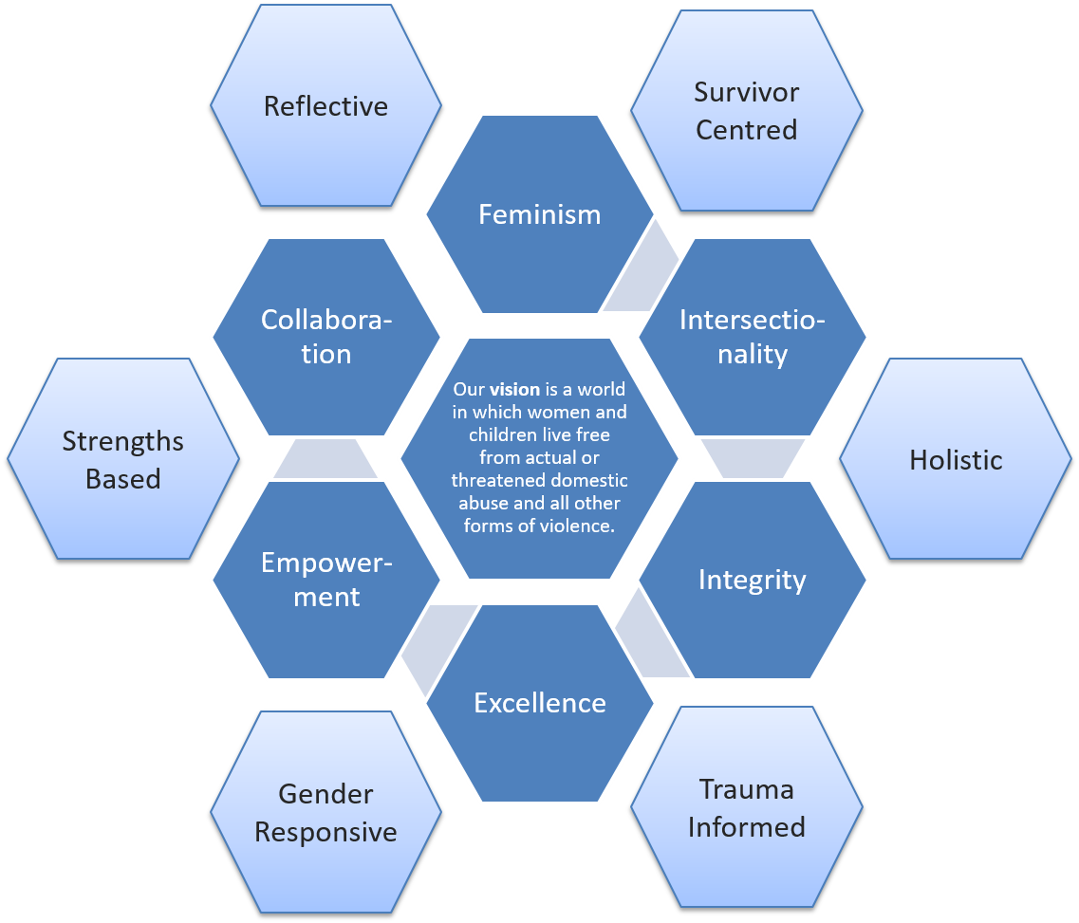

# Our Values

Our **values** inform our work and are founded on gender equality, human rights:

* **Feminism:** We work within a feminist ethos and advocate for women's rights on the grounds of political, social, and economic equality.
* **Intersectionality:** We strive to be a diverse and inclusive organisation for all marginalised groups, recognising intersecting identities and addressing the power imbalance that leads to abuse.
* **Integrity:** We keep survivors’ needs and voices at the centre of our work, hold ourselves accountable for our actions and act according to our beliefs and values.
* **Excellence:** We are a learning organisation and respond to emerging needs and latest research about violence against women and children. We take pride in maintaining high standards throughout the organisation.
* **Empowerment:** We create an environment where women and children can achieve self-determination, exercise their human-rights and flourish.
* **Collaboration:** We work as a team with survivors and partners to develop services, share knowledge and expertise, and to maximise every opportunity to progress towards our vision.

# Our Approach

We aim to work alongside survivors in their recovery from the trauma they have experienced, listen to their needs and help them to draw on their own strengths to build safe and independent futures.

There are six principles to our approach:

* **Survivor Centred** - Each survivor is at a different stage of their journey and has a unique history – there is no one size fits all. We listen, believe and validate. We show empathy and we ask what they want. We see children as survivors in their own right. Being survivor centred ensures we’re getting it right for each survivor. It gives survivors a voice and empowers them.
* **Holistic** - Domestic abuse affects all aspects of a survivor’s life. Therefore we support survivors on their journey to recovery by providing individualised practical and emotional support. Being flexible, creative and listening to survivors about what matters to them enables us to focus support on areas of highest need, leading to more meaningful support and a greater long term positive impact.
* **Trauma Informed** - Trauma can have a long lasting effect on mental health and relationships. It can be caused by coercive control, amongst other things, and lead to behaviour which may seem harmful or counter-productive. We recognise this behaviour as a response to trauma and a coping mechanism. We create safety, build trust, offer choice, work collaboratively, develop knowledge and empower survivors to help them to make meaningful and lasting change and promote recovery.
* **Gender Responsive** - We recognise the gendered nature of domestic abuse. We work with survivors to understand the social context in which abuse exists. We raise awareness of the impact of gender stereotypes on relationships and expectations. We promote healthy and equal relationships. We promote children and young people's right to express themselves freely. Being gender responsive liberates women from feelings of responsibility, guilt and shame. It validates experiences and empowers women to seek fairness and equality in future roles and relationships.
* **Strengths Based** - Survivors are experts in their own lives with knowledge, skills and resources. We help them to recognise their strengths and harness their abilities. This builds trust, respect and empowerment, and enables survivors to create long term solutions that lead to independent lives free from abuse.
* **Reflective** - We create a reflective environment to promote self-development and continuous learning for all team members, including trustees, core staff, practitioners and volunteers. This enables us as individuals and as an organisation to really listen to survivors’ voices and to understand our strengths, areas for development, biases and attitudes, which continually improves our work with survivors.

# Impact

Our survivor centred and holistic approach allows us to make a difference to each individual in a way that is meaningful for them. This is captured through qualitative methods such as stories and testimonials, as well as quantitative evaluation forms.

Below are some examples of the life changing impact of the support our team provides.

An improvement in safety for **89%** of survivors receiving support from our adult IDVA and Outreach service.

**“Without Deven I would have walked out the door of 'One Stop' and never told anyone the truth about the past 17 years. She got me a cup of tea, sat, and was the first person to listen while I talked. She was the first person to make me feel safe. She made me realise that what I had accepted as the norm was not part of a loving relationship and I that did not have to tolerate it anymore. She gave me the strength to walk away and for the first time I did not return. Deven held a mirror to my fears and told me that I was strong enough to fight. She found people to help me when I ready to take the next step and go through the courts. Without her support I would have crumbled in the early days, Deven gave me the confidence to find my freedom.”**

**Testimonial from a survivor accessing our adult IDVA and Outreach service.**

**100%** of boys aged 11-24 and girls aged 11-16 receiving one-to-one mentoring reported an improvement in stability and resilience.

**72%** of children aged 5-11 accessing one-to-one or small group support reported an improvement in health and wellbeing.

**“They were all able to express their feelings in a safe way and thoroughly enjoyed the sessions. We noted an improvement in their wellbeing and engagement with learning, as well as being more able to cope with painful emotions, e.g. falling out with a friend; change of class teacher/routine.**

**Parents also fed back that they felt the sessions were beneficial for their children and were grateful that Jacqi [key worker] kept in touch with them throughout the programme. Parents wished the programme could continue as the children enjoyed it so much but recognise that they need to put the skills taught into practice. All the children have been able to do this without exception.”**

**Feedback received from Sonya Sault, Family Liaison Manager, Tenterden Primary Federation**

# Team and Culture

Rising Sun is a values driven organisation that cares about the wellbeing and development of its team.

We hold monthly whole team meetings to share updates and learnings and invite external speakers to gain awareness of wider issues in the sector and other services available. There are regular opportunities to develop skills through training, shadowing others, attending webinars, leading on projects and longer term courses such as the Independent Domestic Violence Advocate qualification. Each team member receives regular support from their line manager and is allocated a team buddy when they first join to help settle in and get to know the team and organisation.

We have a great team spirit and regular wellbeing activities for everyone to take part in. Highlights have included a trip to Wingham Wildlife Park, fish and chips on Tankerton Slopes and a family picnic and sports day.

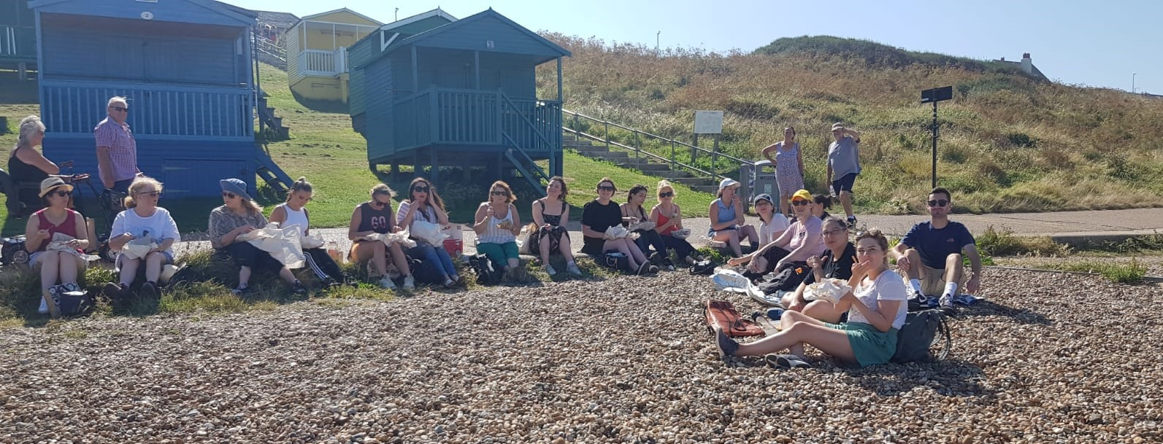

We offer a number of benefits to team members including:

* 25 days annual leave per year
* A day of leave on your birthday
* 3% matched pension contribution
* Access to Rising Sun’s counselling service
* Employee Assistance Programme
* Health care cash plan for you and your children for a number of health treatments (e.g. dental, optical, physiotherapy etc.) and also discounts in shops and attractions
* Up to four weeks sick pay in any 12 month period (eligible after six months’ service)

It is our hope that you will develop and thrive as part of our team of passionate and committed individuals, and contribute to making a difference to the lives of survivors across Kent.

Here’s what some of our current team members say about working with Rising Sun.



I love working for the Rising Sun, it brings me a huge amount of satisfaction knowing I’ve made a positive difference in a survivor’s life. I feel I’m a small part of making a big difference in the district. And the team is such a joy to work alongside – friendly, helpful and passionate about the work they do.

Amy, Trusts and Foundations Fundraising Officer



What I love about working for the Rising Sun is our belief that women are the experts in their own lives. We empower survivors and help them to access the support they need to live free from abuse. It is a privilege to be trusted by survivors through probably one of the most difficult times of their lives, this is something that we never forget or take for granted.

Elaine, Head of Adult Services



From day one, I was drawn by the energy, commitment and positivity from everyone in the team. I was immediately welcomed into the family and I am continually impressed with the dedication and high quality of work going on around me. It feels amazing to be part of such as positive force for good.

Ingrid, Head of Children and Young People Services



Working for The Rising Sun is like working with your favourite family members. The passion that we all have for the work we do is palpable and ultimately we all have the same goal, to safeguard families from domestic abuse. The job can be tough, but it’s certainly rewarding and we have a lot of fun along the way.

Brooke, Independent Domestic Violence Advocate

**Job Description and Person Specification**

Job Title: Domestic Abuse Accommodation Support Worker

Location: Canterbury, Kent

Responsible to: 16 – 24 Domestic Abuse Service Manager

Contract: 1 year fixed term, with the potential for extension

Hours: 22.5 hours a week: days and hours TBC

Salary: £23,400 - £25,192 pa FTE, pro-rated to £14,040 - £15,115 for part time hours

Probation Period: 6 months

Benefits: 25 days annual leave + bank holidays (pro-rated if part time), 3% matched pension contribution, employee health cash plan and discounts scheme

Other info: **This post is restricted to women under schedule 9, Part 1, Equalities Act 2010.**

Closing date: Please complete the application form at the end of this document and return to [claire@risingsunkent.com](mailto:claire@risingsunkent.com) by the end of Monday 2nd December 2024. Applications will be reviewed on a rolling basis so you are advised to apply early.

Start date: As soon as possible

# OVERVIEW

Rising Sun Domestic Violence and Abuse Service (Rising Sun) is an independent charity in Kent working to prevent domestic abuse and improve the lives of survivors and their children suffering from its effects. We have an ambitious vision for a world in which women and children live free from actual or threatened domestic abuse and all forms of violence.

Our team provide a range of services to adults and children who’ve experienced domestic abuse. We understand the impact of domestic abuse on survivors and so we listen to individual needs and respond in a trauma informed way. We provide one-to-one support and also deliver therapeutically informed group programmes to help survivors to recognise healthy/unhealthy behaviours in relationships and to understand the impact of domestic abuse. Bringing survivors together validates experiences and enables them to draw strength from one another.

As part of our passionate and committed team of approximately 50 staff, our aspiration is that you will thrive and develop in this varied role. You will be contributing to the invaluable work of the Rising Sun and making a lasting difference to the lives of those who are impacted by domestic abuse.

**JOB PURPOSE**

Liberty House provides housing and support for up to 5 homeless young women aged 16-24 who are single, pregnant or have a young child and have experienced domestic abuse.

The support worker will be required to take on key-working responsibilities for the residents at Liberty House, as well as delivering other support work within the house and within the wider Liberty team. This could be related to pregnancy and parenting, life skills, psychoeducational support, understanding healthy relationships and building supportive peer relationships within the home, and supporting them to live independently.

The post holder will work to provide a secure, stable and homely environment and to act as a positive role model to residents. They will build professional and supportive relationships with residents and colleagues.

The project works to empower residents, providing them with information relating to their rights and enabling them to make decisions based on their options using a trauma informed approach.

As a member of the Liberty Team (16 – 24 year olds), the successful applicant will work collaboratively with the rest of the Children and Young People’s team, as well as the wider Rising Sun team to support other programmes delivered within the organisation.

**MAIN DUTIES AND RESPONSIBILITIES**

**Service Delivery**

* Provide holistic, trauma informed, practical and emotional support to residents of Liberty House through regular 1-2-1 sessions. Develop individual support plans, which address any practical and emotional needs the resident may have, such as accessing benefits, life skills and perform risk assessments where needed.
* Organise and deliver group sessions that focus on life skills and strengthening relationships.
* Encourage the residents in positive parenting.
* Manage relationships within the house, act as a conciliator, arbitrator and reconciler in disputes between residents.
* Ensure residents adhere to house rules.
* Assist with the day to day general running of the house and office, to ensure they are fit for purpose and safe for team members and residents.
* Conduct safety checks around the house. Ensure all faults/repairs are reported and that the Health and Safety Policy is adhered to at all times.
* Comply with organisational policies and procedures and adhere to confidentiality.
* Work effectively in partnership with other agencies.
* Work within our ethos of Equality, Diversity and Inclusion at all times and instil these values in all areas of work, with service users, staff and external stakeholders.
* Encourage residents’ participation in service development, continuous improvement and feedback exercises
* Maintain up to date and accurate records and ensure reports and evaluations are completed as required.
* Be willing and available to work some evenings and weekends as required, as part of a rota for Liberty House team members, and also occasionally to support wider team activities such as representing Rising Sun at events (time off in lieu can be taken by arrangement with your line manager).
* Represent Rising Sun at multi-agency meetings as required.

**General**

* Demonstrate a commitment to continued professional development, being responsible for personal learning and keeping up to date on research, relevant legislation, policy and practice, and other literature relevant to the role.
* Uphold the rights of women, children and young people who have experienced domestic abuse, and proactively assess the gender specific, trauma informed needs and the safety of children and women to ensure that any risks/needs identified are addressed, having full regard to Rising Sun Safeguarding Children policy and Safeguarding Adults policy.
* Lone working as required.
* Participate in clinical supervision, training and meetings as required.
* Work across teams and undertake such other duties, appropriate to the grade and nature of the work, as may reasonably be expected.

*This job description sets out the duties of the post at the time when it was drawn up and will be reviewed from time to time. Duties may vary from time to time without changing the general character of the duties or the level of responsibility entailed. Such variations are a common occurrence and cannot of themselves justify a reconsideration of the grading of the post.*

**PERSON SPECIFICATION**

**Knowledge and qualifications**

* Good understanding of antenatal and postnatal care.
* Good understanding of effective parenting, particularly for parents of young babies.
* Good understanding of the impact of domestic violence and trauma on survivors, children and young people, families and communities.
* Knowledge of issues affecting survivors, and an understanding of the barriers they may face in accessing support.
* Thorough knowledge of safeguarding practice, procedures and legislation.
* Good understanding of the operation of the agencies working together to support survivors and their children such as social services, housing, police etc.

**Experience**

* Experience of working with young children and/or babies and their mothers
* Experience of supporting women with life skills/developing confidence
* Experience of multi-agency partnership work
* Experience of working alongside volunteers (Desirable)
* Experience of working with survivors affected by domestic and/ or sexual abuse (Desirable)
* Experience of facilitating group programmes (Desirable)
* Experience of working for a charity or not for profit organisation. (Desirable)

**Skills**

* Excellent listening, written and verbal communication skills.
* Ability to form positive relationships with residents from a wide range of backgrounds and life experiences in order to build professional and supportive relationships
* Ability to work closely with young parents and their babies
* Ability to help residents in the creative use of leisure time with a view to building relationships and social skills
* Non-judgemental and non-directive approach to empowering survivors along with the ability to understand the individual needs of clients.
* Ability to manage conflict and to promote resolution.
* Ability to work well with colleagues, statutory and non-statutory agencies and responsibly on own initiative.
* Good task management skills and the ability to work effectively under pressure and to deadlines.
* Good data collection, monitoring and IT skills, including word processing and using databases and Excel spreadsheets.

**General**

* Able to set clear boundaries and a willingness to accept line management and make effective use of clinical supervision.
* A good understanding and commitment to confidentiality, safe practice and health and safety procedures.
* A good understanding of cultural issues, and commitment to anti-discriminatory practice and equal opportunities.
* Able to travel independently across East Kent where necessary to attend meetings.
* Willingness to carry out the policies and procedures of the Rising Sun and to work within its framework and core values.

# Equal Opportunities Statement

Rising Sun is an equal opportunities employer. We recognise intersecting identities, and value what having a diverse team brings, both in terms of effectively responding to client needs, and engaging with each other at work. We encourage applicants from all sections of the community; especially from minority groups/groups with a protected characteristic such as B.A.M.E., who are currently underrepresented at Rising Sun. We are disability-friendly, and flexible working is available in the majority of roles. We strive to offer accommodations to all applicants who need them.

# Safeguarding Statement

Rising Sun is committed to safeguarding those we provide a service to. The successful candidate will be required to undergo a DBS (Disclosure and Barring Service) check, a ‘right to work check’ in accordance with UK government Home Office guidelines, and to provide two references*.*

# APPLICATION INFORMATION

To apply for the role please complete the application form at the end of this document and return to [claire@risingsunkent.com](mailto:claire@risingsunkent.com) by the end of Monday 2nd December 2024.

We will be screening applications and inviting suitable candidates to interview on a rolling basis so we advise applying early to avoid disappointment.

It is important that the post holder has the required personal attributes and holds values and ethics in line with those held by the organisation; therefore, an applicant with the willingness to learn and be flexible may still be considered if they have qualities, which do not directly match all of the above criteria.

Please note that the successful candidate will be offered the job subject to a DBS (CRB) check and suitable references.

# Contact Details

For further information visit our website at [www.risingsunkent.com](http://www.risingsunkent.com) and if you have any questions about your application or wish to discuss the role further please contact Chrisi, the 16 – 24 Domestic Abuse Service Manager, at [chrisi@risingsunkent.com](mailto:chrisi@risingsunkent.com) or 01227 767180.

**We request no contact from agencies or media sales please.**

# Rising Sun Application Form

|  |
| --- |
| **Post applied for:** Domestic Abuse Accommodation Support Worker |
| Title:  Full name:  Address:  Telephone no.:  E-mail address:  How / where did you hear about the role? |

|  |  |  |  |
| --- | --- | --- | --- |
| **Education and Qualifications** | | | |
| Type of qualification | Subject/Title | Grade/level | Date completed |
|  |  |  |  |
|  |  |  |  |
|  |  |  |  |
|  |  |  |  |

|  |  |  |  |
| --- | --- | --- | --- |
| **Employment History**  Please begin with the current or most recent; the past ten years is sufficient, but please add any other roles if relevant. **If a role was not full time, please state days per week.** | | | |
| Job Title | Employer | Role/responsibilities (please give a brief description of what the work involved) | Dates From – to (mm/yy) |
|  |  |  |  |
|  |  |  |  |
|  |  |  |  |
|  |  |  |  |
|  |  |  |  |

|  |  |  |
| --- | --- | --- |
| **Relevant training or other work related experience** (e.g. voluntary work) | | |
| Course / Organisation | Dates | Brief Description |
|  |  |  |
|  |  |  |
|  |  |  |
|  |  |  |

|  |
| --- |
| **Personal statement**  Please say why you are applying for this job, explaining how you meet the requirements of the person specification, and include any other relevant experience. (Continue on another page if necessary) |
|  |

|  |  |
| --- | --- |
| **Right to Work in the UK**  All applicants must have the right to live and work in the UK on application: we are not registered with the home office for visa sponsorship, and are obliged to check the Right to Work of every new team member. | |
| Do you have the unrestricted right to live and work in the UK? |  |

|  |  |
| --- | --- |
| **Rehabilitation of Offenders Act**  This post is exempt from the provisions of the Rehabilitation of Offenders Act 1974. You must therefore disclose any Criminal convictions, including spent convictions, suspended sentences and bind over orders | |
| **Have you ever been convicted of a Criminal Offence or received a Caution?** If yes, you may be asked to supply details. | YES/NO |
| **Please note that all posts require a DBS Check.** | |

|  |  |
| --- | --- |
| **Car/Driving** (not essential for this post) |  |
| Do you hold a Full Driving Licence? |  |
| Do you have access to a vehicle for this job? |  |
| Please give details of any current endorsements and any pending offences |  |

|  |  |
| --- | --- |
| **References** (Please provide two referees: one of which should be your current or most recent employer. They will only be contacted after a job offer is made and accepted.) | |
| Reference 1  Name:  Organisation:  Job title:  Relationship to applicant:  Phone number:  Organisation email:  Reference 2  Name:  Organisation:  Job title:  Relationship to applicant:  Phone number:  Organisation email: | |
| Signature | Date |

Please return your completed application to [claire@risingsunkent.com](mailto:claire@risingsunkent.com) by the end of Monday 2nd December 2024.

**Equality Monitoring Form**

We would be grateful if you would please complete our anonymous Equality Monitoring Form by clicking on the link below:

<https://forms.office.com/r/bsVPQKVmH2>

This will help us to monitor equalities information and ensure that we are treating all candidates fairly and appropriately in line with our equality policy.

This information will be treated confidentially in line with our data protection policy and will not be used in any part of the selection process. Filling out this form is completely voluntary, and if you'd rather not share some of this information with us, each question has a 'prefer not to say' option or you can just leave it blank.

If you have any questions about the form, please contact [claire@risingsunkent.com](mailto:claire@risingsunkent.com).

Thank you for completing this form.